**AFRL Research Collaboration Program**

**Contract FA8650-13-C-5800**

**Effect of Constituents and Microstructure on Energy Dissipation Mechanisms During Damage Growth**

**University: Texas A&M University**

**REPORT COVERS PERIOD: 4-1-18 THRU 3-31-18**

1. **PROJECT TEAM MEMBERS**
2. **LEAD UNIVERSITY POC:** John Whitcomb, 979-845-4006, jdw@tamu.edu
3. **PROJECT TEAM MEMBERS:** John Whitcomb, Collin Blake
4. **AFRL TECHNICAL POC:** Craig Przybyla
5. **TECHNICAL DISCUSSION**
6. **CURRENT WORK**Development of the infrastructure to perform mesoscale analysis of 3D textile composites.

**Approach**

VTMS conducts a four-step process to generate geometric textile models. The output of each step is illustrated in Figure 1. Generally, the volume model of the tows (Figure 1.d) contains interpenetrations of the tows, which are obviously physically impossible. The tows in Fig. 1d are actually just hollow tubes with an unusual cross-section. The interior of the tows is considered later.

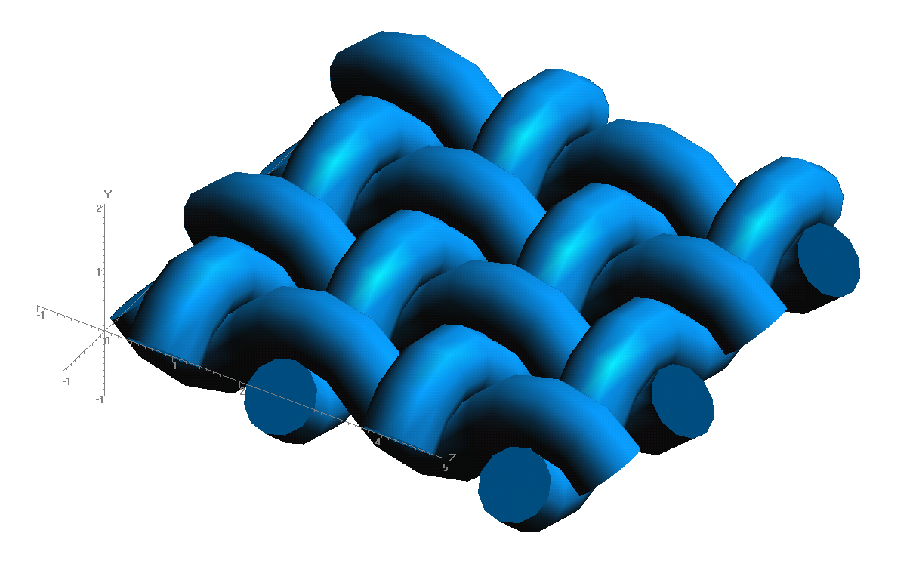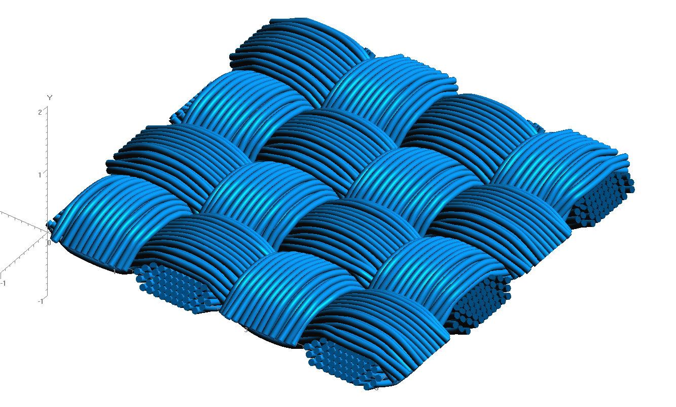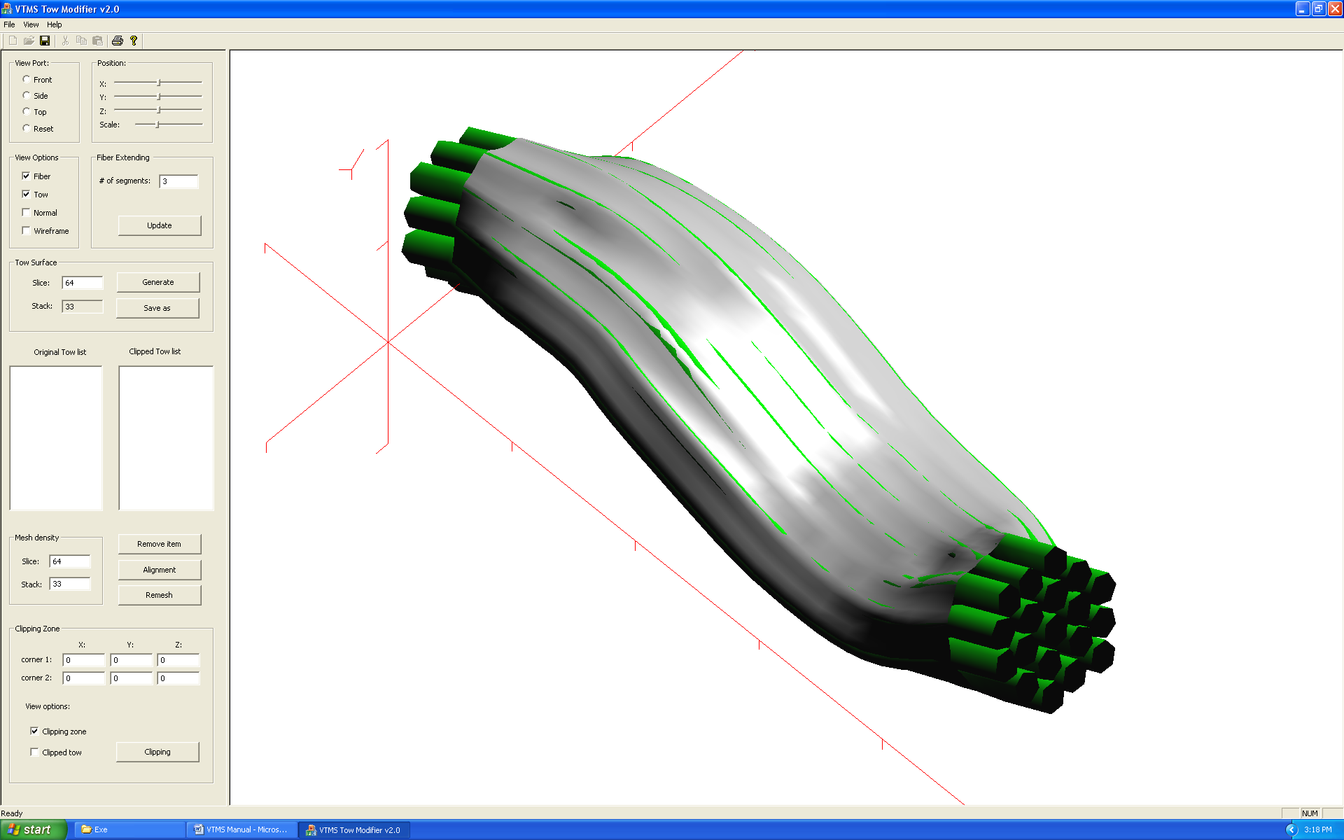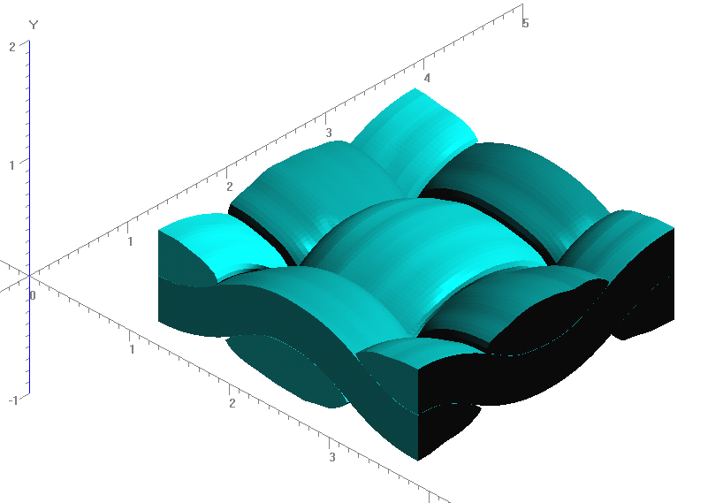

**Figure 1: Evolution of Weave Tow Geometry**

**a) Generic Approximation of Woven Pattern**

**b) Filament Representation of Pattern**

**c) Surface Approximation of Filament Bundles**

**d) Volume Model Derived from Surfaces**

Figure 2 shows a representation of a series of inter-penetrations between two of these tows. Figure 2.a) shows a section of two tows in close proximity. Figure 2.b) shows how the penetrations look. Although the interpenetrations are typically small, there are multiple regions that must be fixed, since a finite element mesh cannot have such regions.

A library (SISL) that is a freely available is used to describe 3D surfaces as NURBS and then identify interpenetrating regions. The regions returned from the library are described by multiple boundary curves (Figure 3) that are made to be unique and closed.

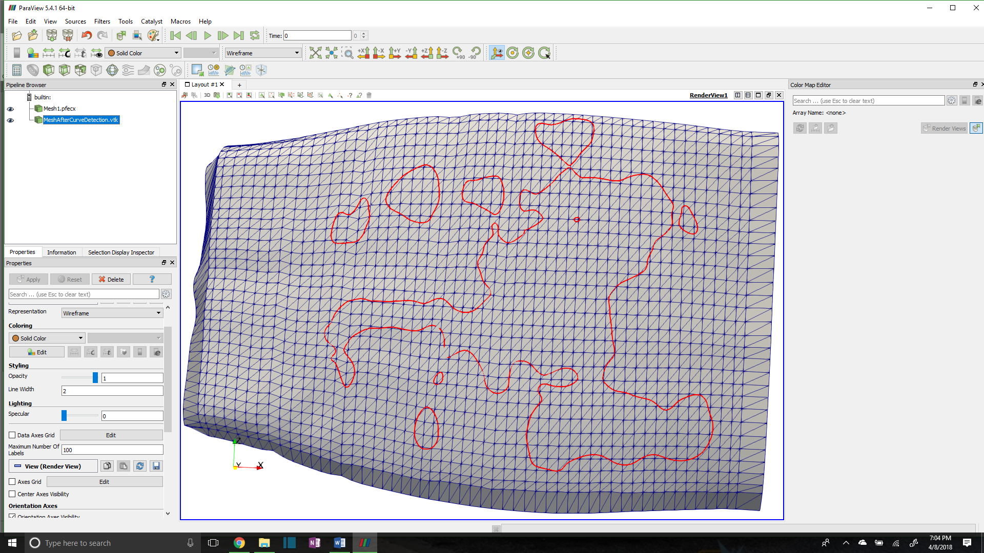

**Figure 3: Surface mesh with intersection boundary curve**

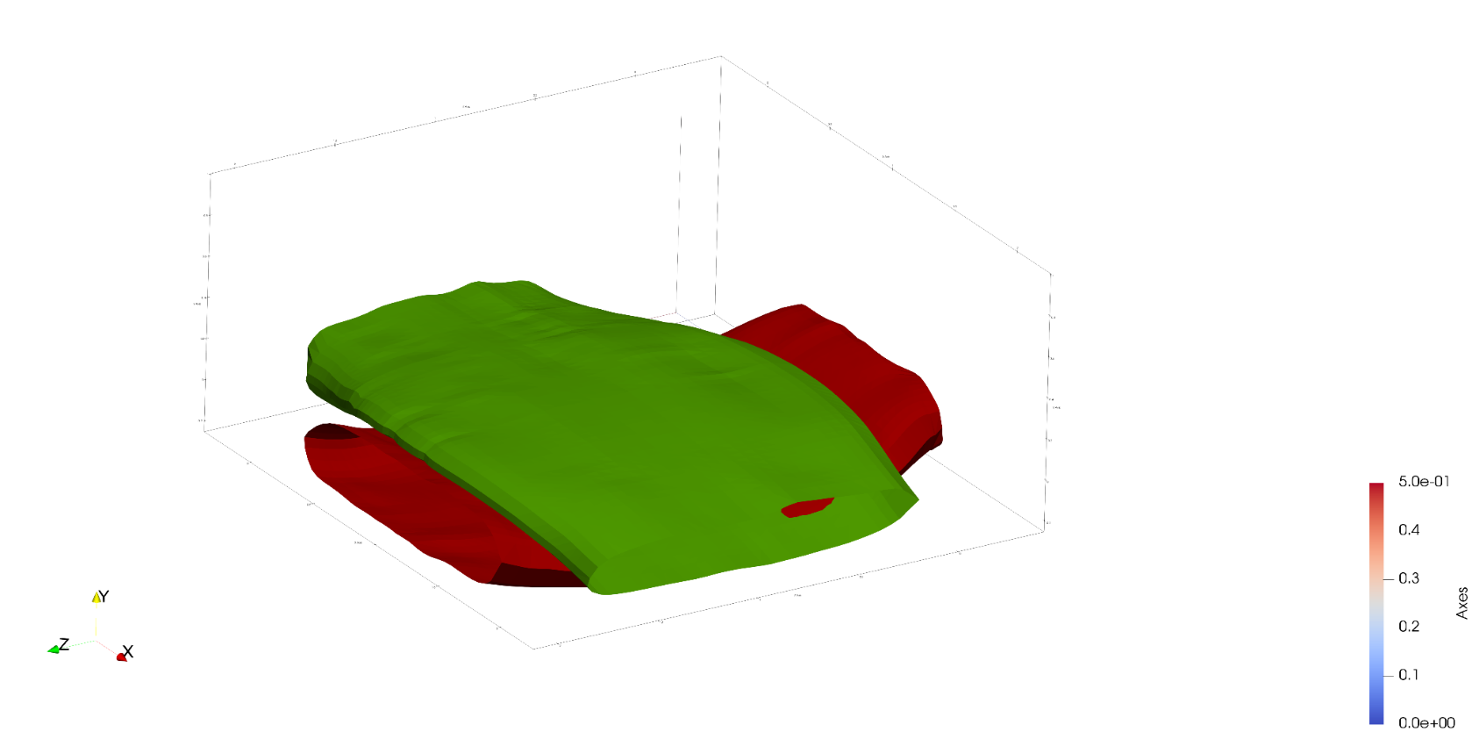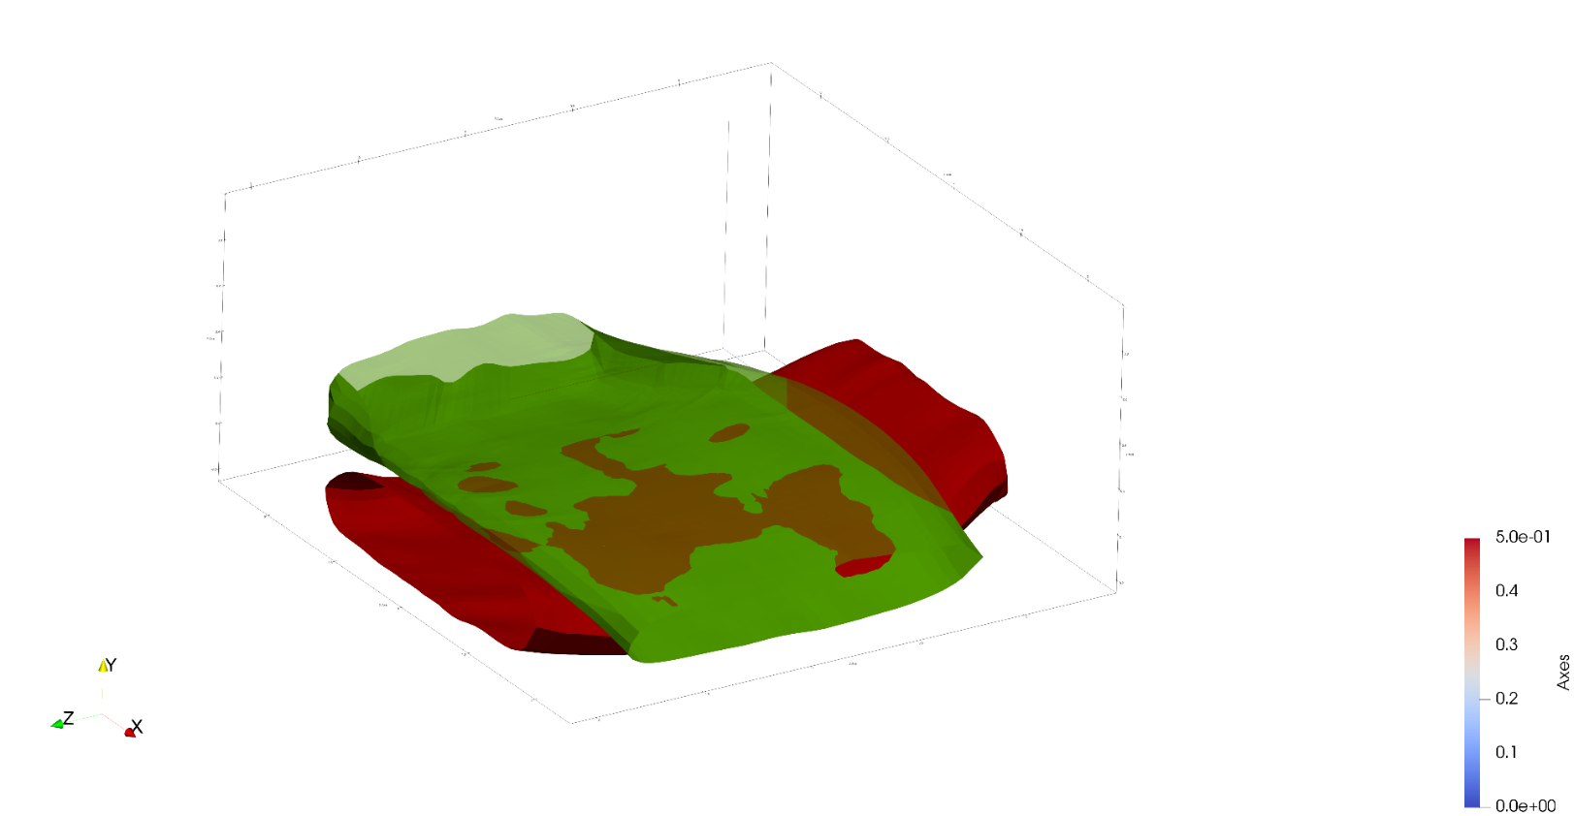

1. **Transparent upper tow showing interpenetrations**
2. **Tows in close proximity**

**Figure 2: Region of close tow geometries with interpenetrations**

To identify which elements are intersected, and to refine the boundary curve where it intersects surface elements, the Separating Axis Theorem (SAT)**[1]** is implemented. We employ this algorithm for every intersection along both tows and their elements. This results in a boundary curve that is compatible with the two surface meshes where they intersect each other. This gives the information needed to enforce compatibility between the two surfaces.

The next step it to re-mesh the elements that have been intersected so that the shape of the curve can be captured within the surface mesh of both of the tows. After we sub-mesh each individual element on both tows, we can add them back to the original mesh. The result is shown in Figure 4 and 5. Figure 4 shows only one boundary curve sub-meshed and appears as a thick blue line due to the refinement of the elements around the curve. The red lines show the remaining boundary curves that have yet to be sub-meshed in this figure.

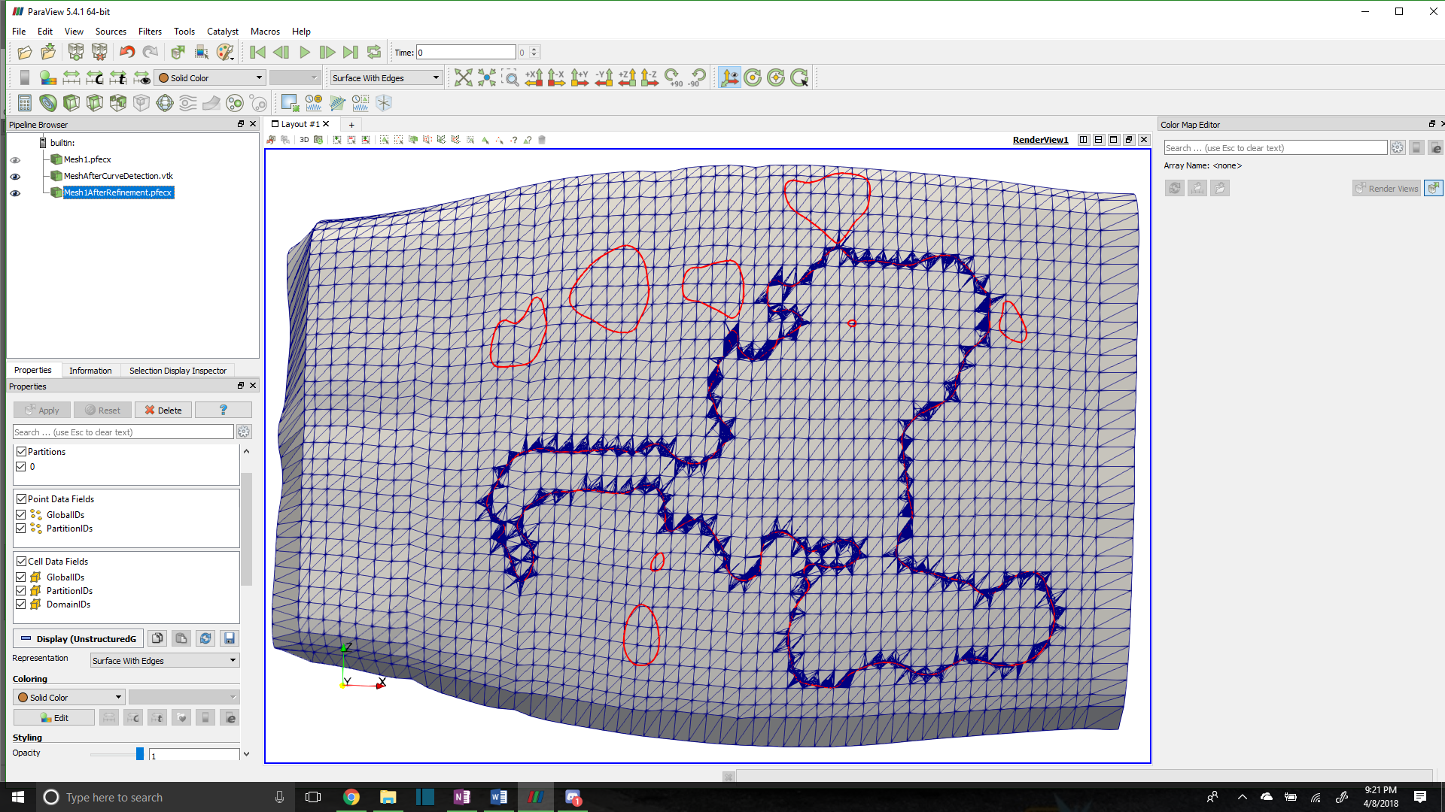

**Figure 4:Tow surface mesh with one boundary curve meshed**

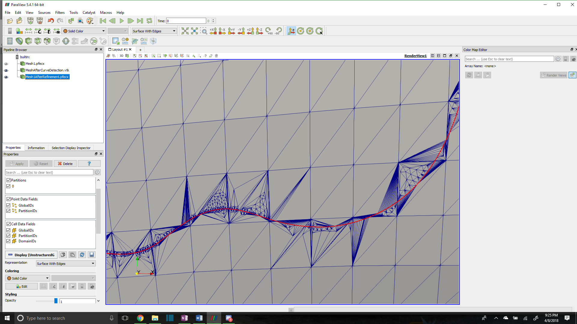

**Figure 5: Close in view of problem elements along boundary curve**

Figure 5 shows some problem elements that are too high aspect and will cause issues when attempting to mesh a compatible matrix around the tow. This will also cause inaccurate results when trying to run an analysis on the resulting mesh. Therefore, a couple of methods were developed to help reduce the refinement of the boundary curve and the resulting mesh.

One issue this the high refinement of the boundary curve compared to the tow surface mesh. It is common that there are more than 8 or 9 boundary curve segments within one surface element. This level of refinement is useful for capturing interpenetrating elements but has negative effects when trying to mesh. The first method implemented was to reduce the refinement of the boundary curve. The method to fix this is to record which nodes are added to the boundary curves due to intersections with surface elements from both tows. The method then removes most of the boundary curve points that lie between any two element intersection nodes. This results in the solution potentially losing some of the features of the boundary curve but will ensure that the tows no longer penetrate in the boundary curve regions. If the intersection points between the boundary curve and both surface meshes are kept, compatibility can be assured along the boundary curve. Although some features may be lost, this method will still catch both node into face interpenetration and edge to edge interpenetrations. The result of the first method is shown in figures 6 and 7.

**Figure 6: Reduced Refinement Meshed Intersection Boundary Curve**

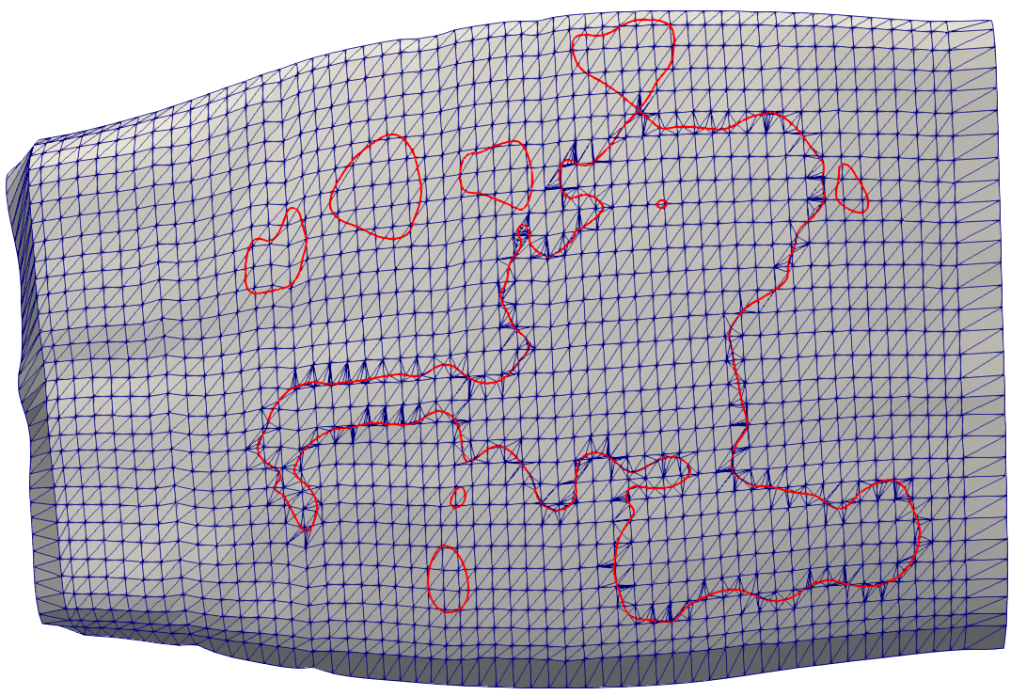

Figures 5 and 7 can be compared as they are the same section of boundary curve. The number of high aspect ratio elements is significantly reduced. However, there is still some evidence that these elements exist. They arise from when the boundary curve is too close to a surface element node. A second method was developed that moves any surface nodes that are close to the boundary curve to this boundary curve. This still allows for accurate detection of interpenetrating nodes as this method is used before the curve is coarsened by the previous method. Figures 8 and 9 show how this method further helps to coarsen the mesh introduced by the boundary curve while still maintaining the shape of the boundary curve. There are still some special case issues that arise with these new methods. Figure 10 is a picture indicating such an issue. The red curve is the original boundary curve. The green is the resulting curve from the two coarsening methods mentioned above. The blue is the resulting mesh that includes the green curve.

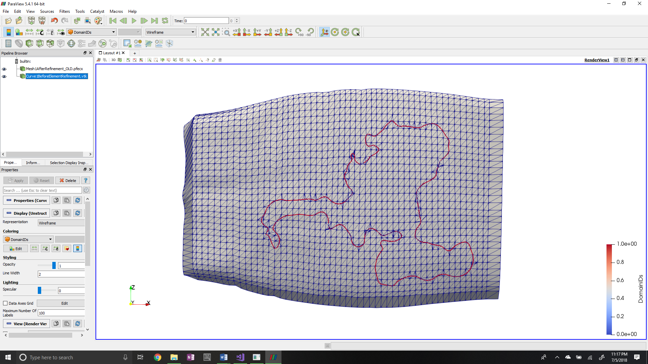

**Figure 8: Lowest refinement with adjusted surface mesh nodes**

**Figure 7: Up-close View of Reduced Refinement**

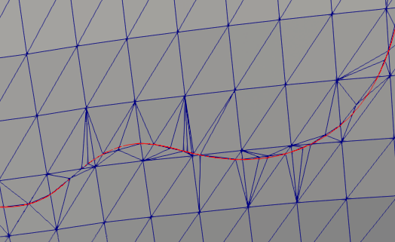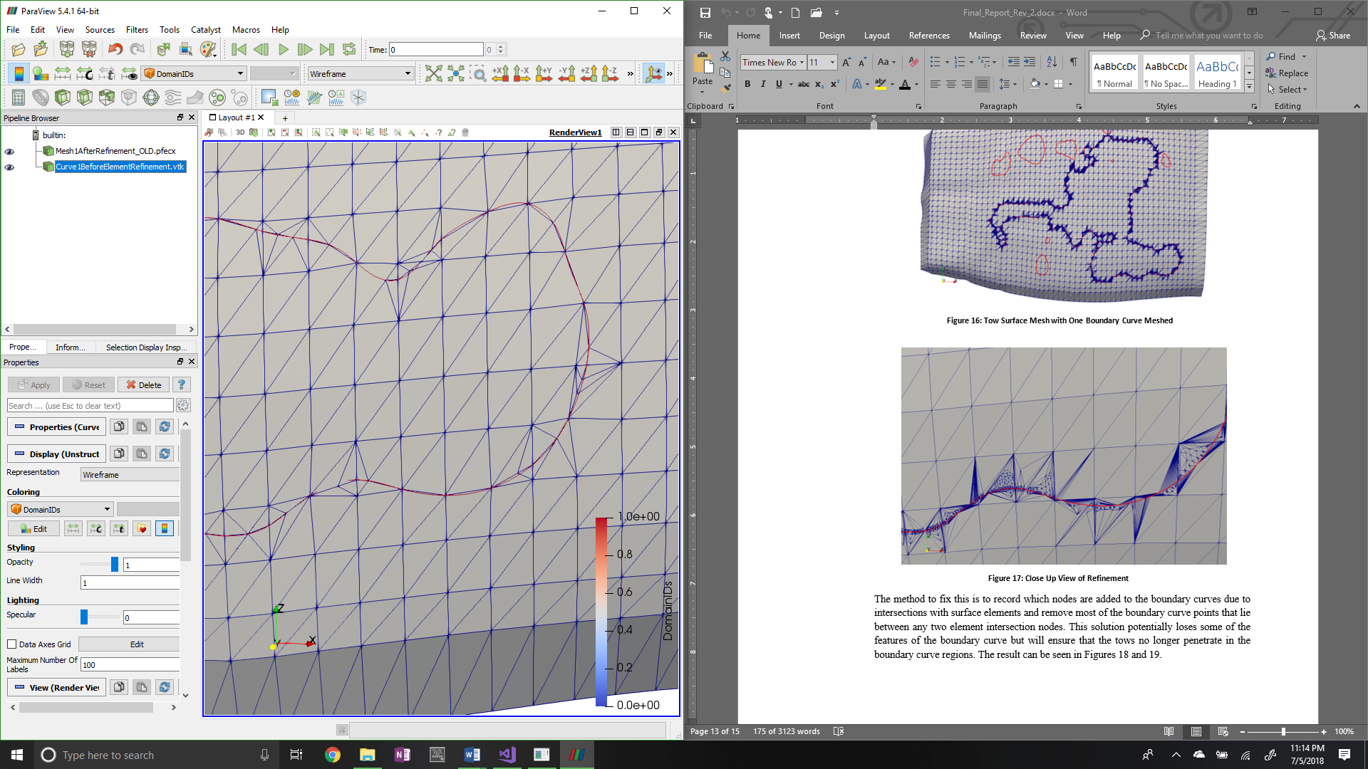

**Figure 9: Close-up view of lower refinement with adjusted surface nodes**

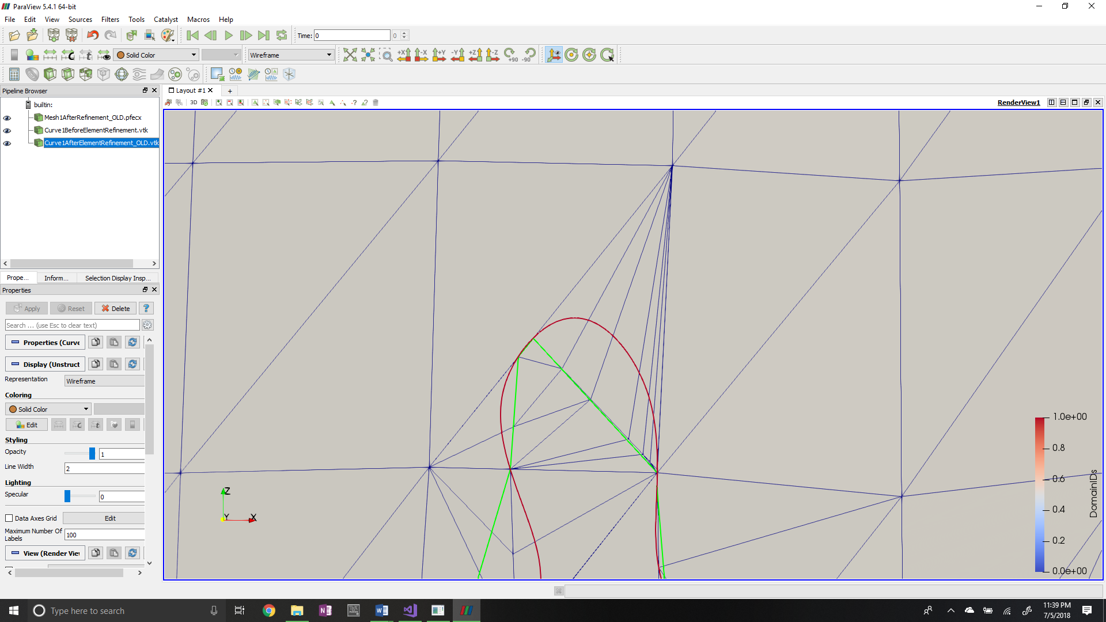

**Figure 10: Special case of undesired sub-meshing result**

There still exists some high aspect ratio elements that will cause issues. These special cases are the current focus of development and is the last problem to be fixed in the sub-meshing routines.

1. **CONCLUSIONS/ANALYSIS TO DATE**

Work on the development of the sub-meshing routines that use the boundary curve have resulted in coarser meshes that have a better potential for being used in an analysis. These meshes also have a much lower occurrence of high aspect ratio elements. There still exists special cases where they occur. These cases are the focus of current development and is the last problem to be solved concerning sub-meshing of the surface meshes.

1. **WORK FORECAST AND PLANS**The special case high-aspect ratio elements will be the focus of development. Once this step is complete an algorithm will be developed to collect all elements that are enclosed by the boundary curve. When this is accomplished, a decision will be made on how to properly solve the interpenetrating elements.